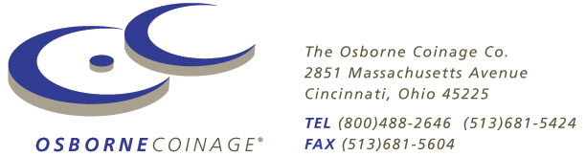

For Immediate Release
June 30, 2008

University Issues Custom Coins to Commemorate Special Season

Cincinnati, OH – When officials at Florida State University sought to commemorate a special football season, they minted a series of custom coins – one for each home Seminoles home game. Each coin bears the Florida State logo on one side and a specific design on the other. Originally produced to be distributed to special guests to the Presidents Box, the coins were so popular that a “general consumption” series was also produced and sold by retailers including campus bookstores.

Among the special designs are “Sportsmanship” and “Unconquered” both featuring renditions of their namesake statues which are located on the football plaza. “Sportsmanship” is an 11-foot tall statue located outside the football stadium, while “Unconquered” is a twice-life-size statue of Chief Osceola with spear in hand atop his rearing horse Renegade. In addition to showcasing new additions to the campus, the custom coins also honor older staples of University life. For example, one coin featured a University founder Francis Epps, another paid tribute to coaching legend Bobby Bowden, and a another depicted Westcott Hall – the first academic building on the FSU campus. The final coin depicts a stained glass window which was recently unveiled at the football stadium commemorating the naming of Bobby Bowden Field at Doak Campbell Stadium.

The coin sets, which were offered during the 2005 season, were quite popular, despite a lackluster year on the field. “If we had won the national Championship” surmises Awards4U President Sam Varn (who conceived the idea and designed the series) “we would have sold out. As it was, we still sold quite a few sets.”

In addition to commemorating special seasons, inaugural events, retirements, and renaming of facilities, commemorative coins are also used by FSU for new construction projects or major renovations. Minted in small quantities and given to those whose efforts helped bring the project to fruition, the coins feature the FSU logo on one side and a 3-dimnsional rendition of the building on the reverse.

“Custom coins are a great way to commemorate special occasion like new or renovated buildings” says Varn, “everyone involved in the project appreciates being remembered with such a unique keepsake.”

For more information on Osborne Coinage visit www.osbornecoin.com, or call(866) 274-0868. For more information on Awards4U visit www.awards4u.com.

-xxx-



